1. **HOW TO CREATE S3 BUCKET FROM AWS CONSOLE AND UPLOAD A FILE TO IT**
2. Type S3 in search bar >> Click on the link to open(This screen shows up when you are creating your first s3 bucket, otherwise you will see a list of buckets)

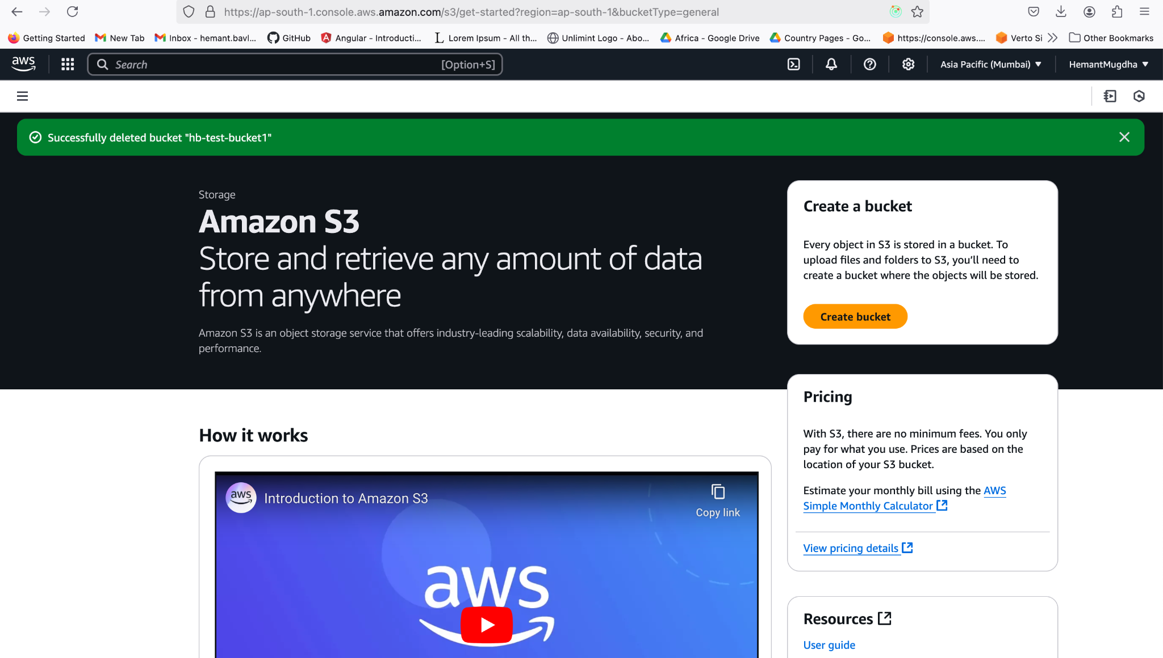

1. To create a bucket >> Click on Create Bucket
   1. Provide a name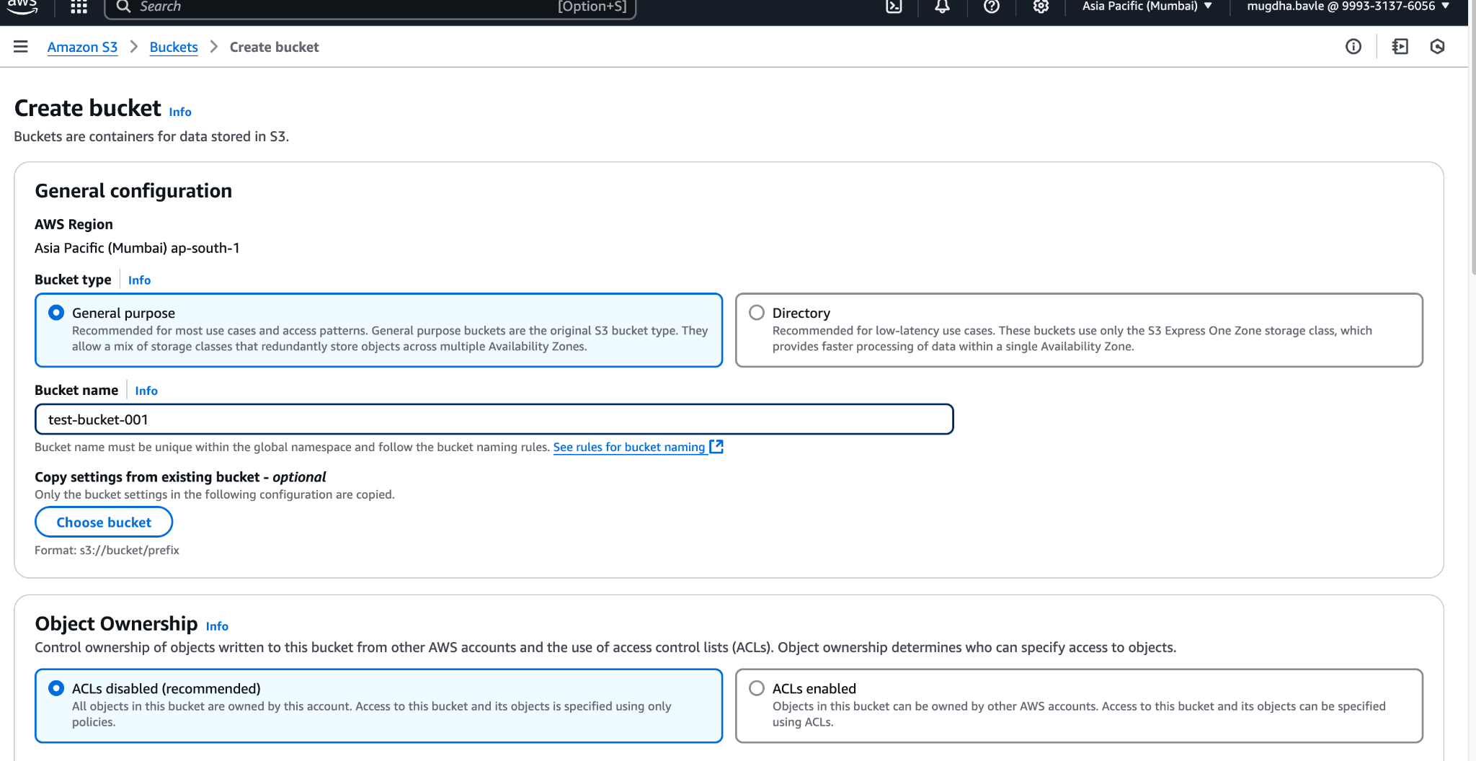
   2. Leave every other setting as it is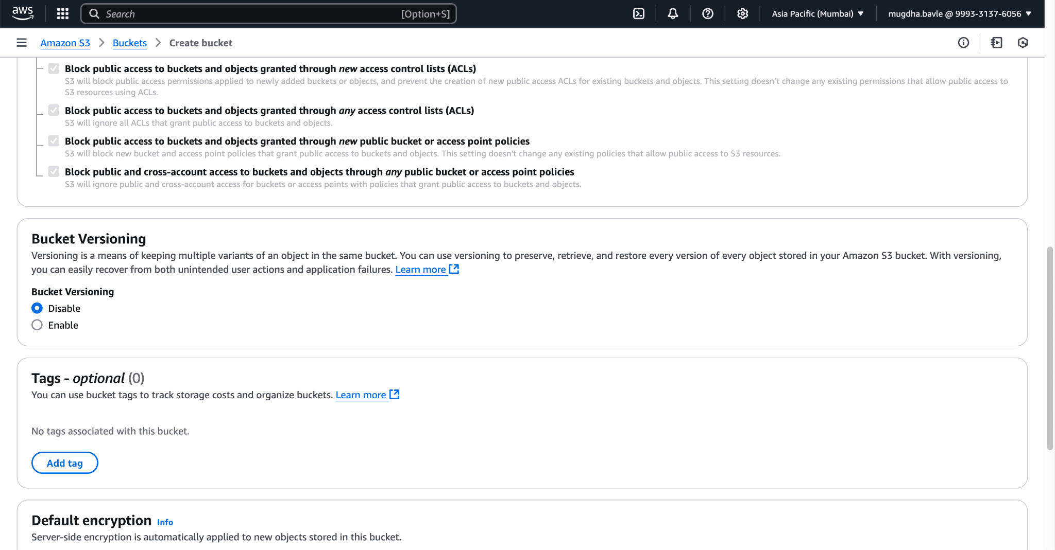
   3. Click on create bucket at the end of the screen.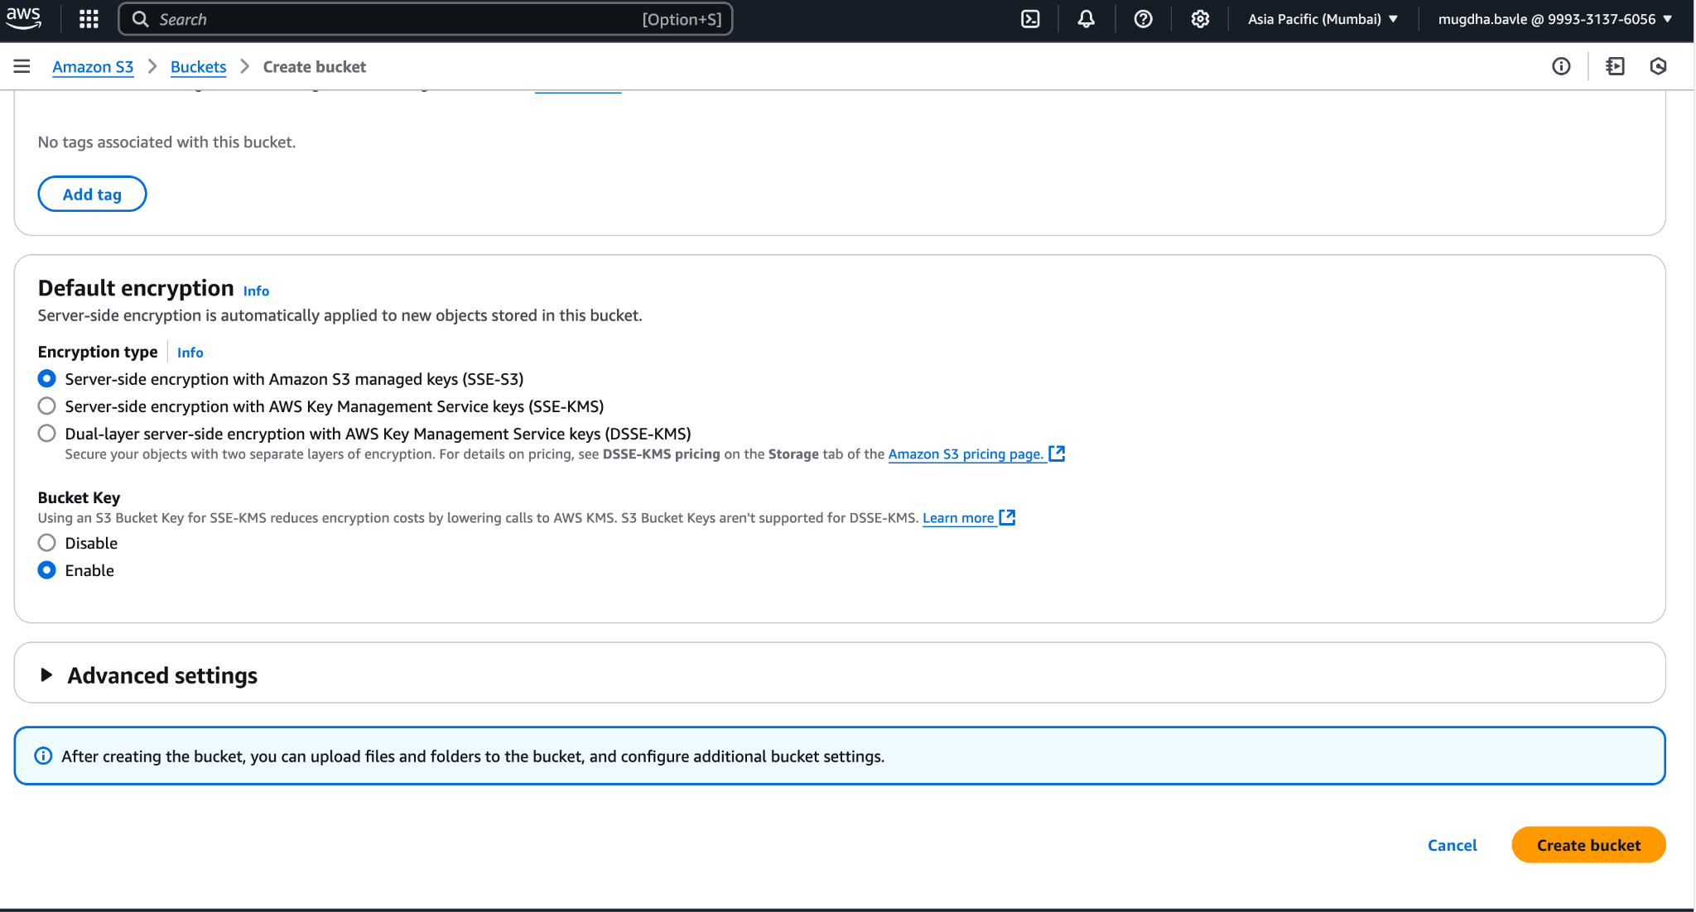
   4. When the bucket is successfully created. It will show a success message in green panel as shown below: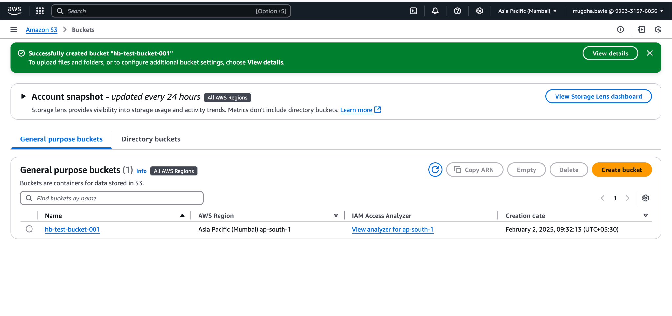
2. To Upload a file, select the bucket shown in Step 2->d. It will open the bucket details page as shown in screenshot below.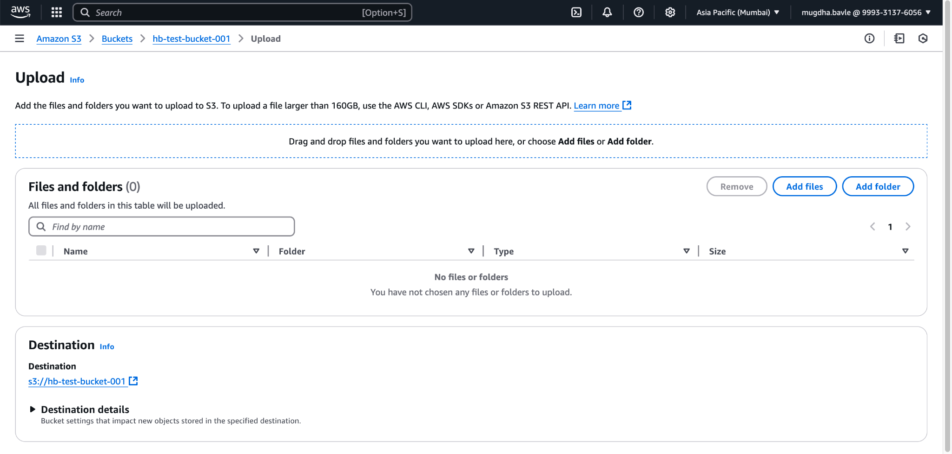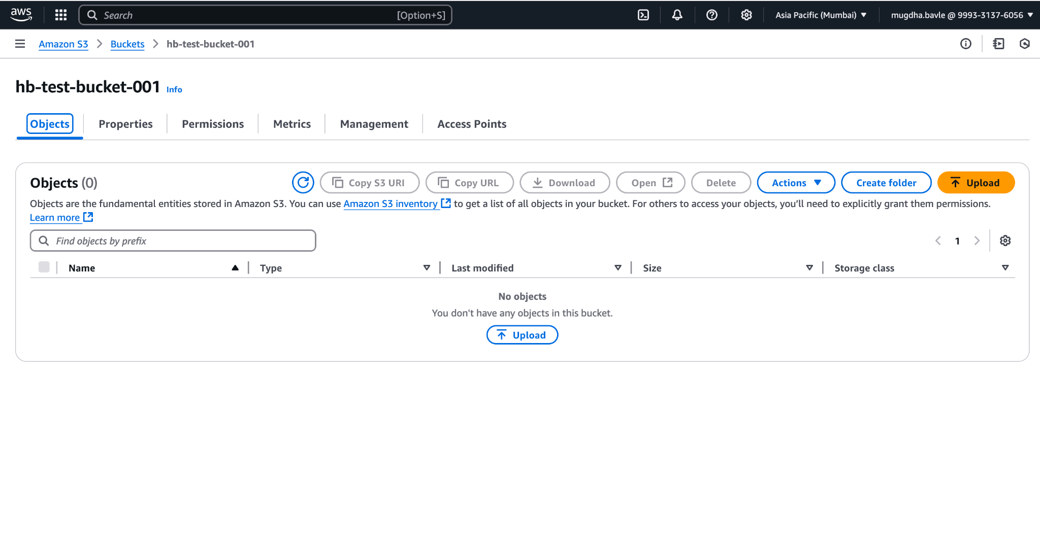
3. Click the Upload Button to open file upload page >> browse and select the file you want to upload and click open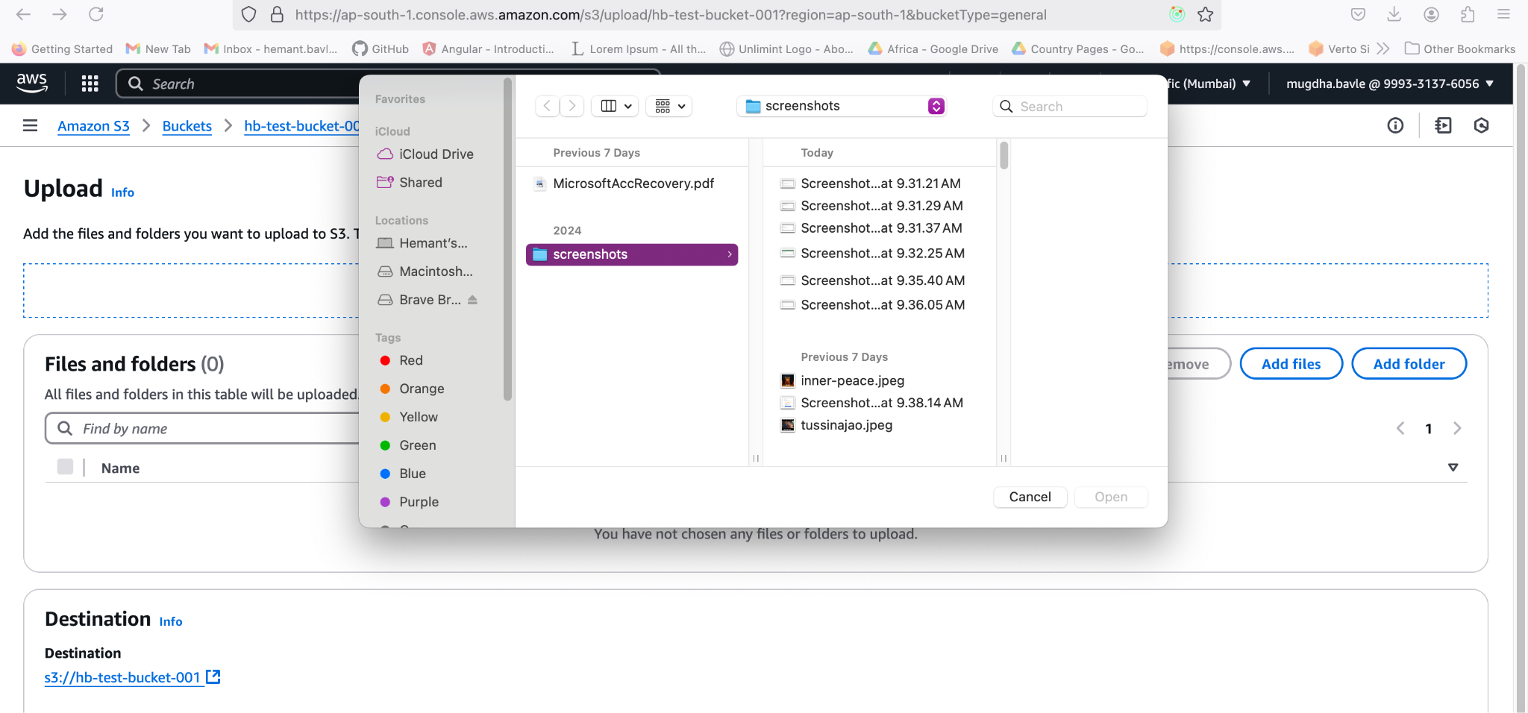
4. Once the file is selected it will show up in the object list.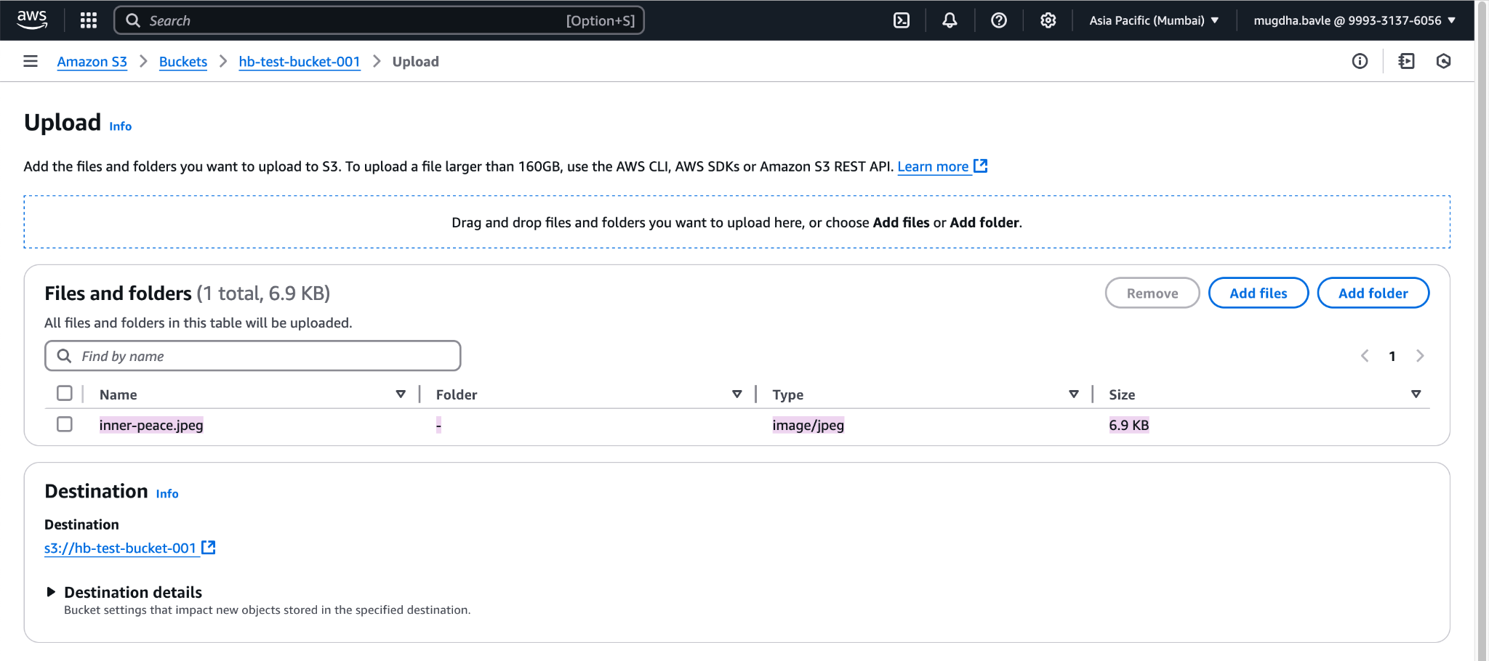
5. Scroll below and click on upload to finalize the upload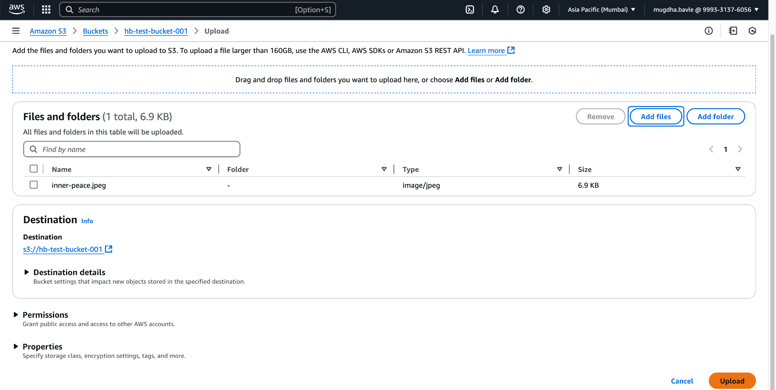

2. **HOW TO CREATE A FILE IN COMMAND LINE AND UPLOAD IT TO S3 BUCKET USING AWS CLI AND CHECK THE CONTENTS OF IT**

1. Open the bucket details page created in previous assignment
2. You can create and EC2 instance/Or use your own command line. Make sure it has a minimum of S3 PutObject permission. I have give S3FullAccess.
3. You can use the following commands to create a file from command line

, #_

~\_ ####_ Amazon Linux 2023

~~ \_#####\

~~ \###|

~~ \#/ ___ https://aws.amazon.com/linux/amazon-linux-2023

~~ V~' '->

~~~ /

~~._. _/

_/ _/

_/m/'

Last login: Sun Feb 2 04:31:24 2025 from 219.91.170.219

[ec2-user@ip-172-31-5-188 ~]$ sudo su

[root@ip-172-31-5-188 ec2-user]# touch hb-test-file.txt // You can create a file with this

[root@ip-172-31-5-188 ec2-user]# ls // check the file using ls command

hb-test-file.txt somefile

[root@ip-172-31-5-188 ec2-user]# aws s3 cp hb-test-file.txt s3://hb-test-bucket-001 // this is used for copying the file

upload: ./hb-test-file.txt to s3://hb-test-bucket-001/hb-test-file.txt // On successful upload this shows up

[ec2-user@ip-172-31-5-188 ~]$ aws s3 help

[ec2-user@ip-172-31-5-188 ~]$ aws s3 ls s3://hb-test-bucket-001 //This command list all files in S3 bucket on CLI

2025-02-02 04:47:16 0 hb-test-file.txt

2025-02-02 04:34:23 7111 inner-peace.jpeg

**3. HOW TO ENABLE VERSIONING AND OBJECT LOCKS IN AN S3 BUCKET**

1. Go AWS console home, type S3 and click to open AWS S3 home page. Click on buckets you shall see the following screen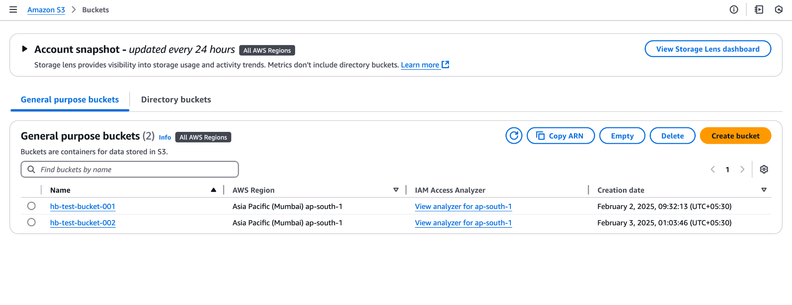
2. Select and Click on the name of the bucket to open the details page of the bucket as shown below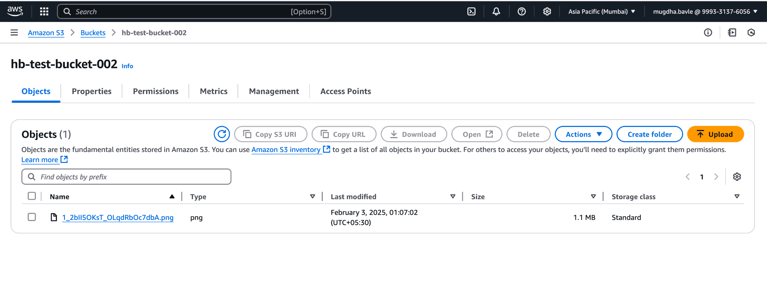
3. You will see 6 tabs on the details page
   1. Object
   2. Properties
   3. Permissions
   4. Metrics
   5. Management
   6. Access Points
4. Click on the **Properties** tab >> Click on the Edit button on the right in **Bucket Versioning** section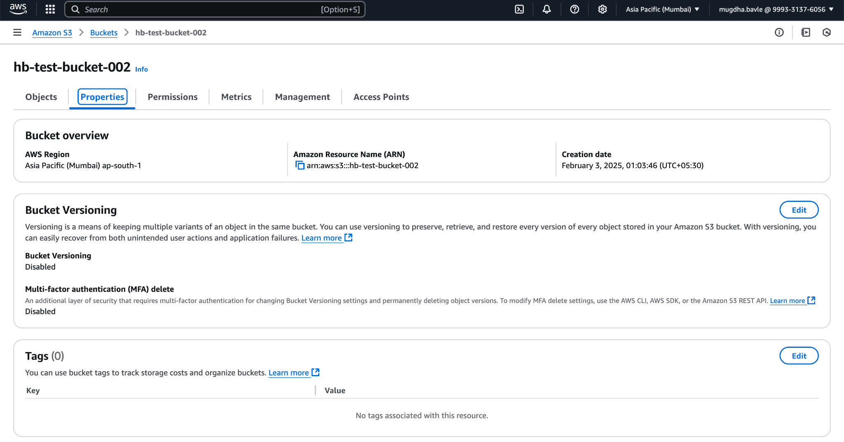
5. There will be 2 options shown
   1. Suspend - This is selected by default
   2. Enable- To enable the versioning, change and select this option.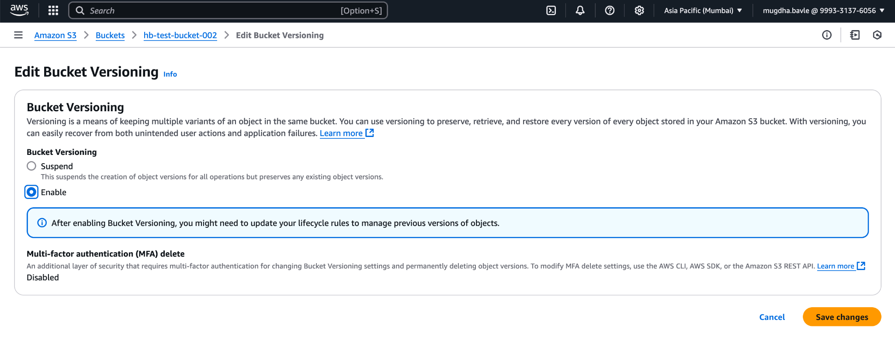
   3. Click on **Save Changes** button. If successful, it will show a green alert at the top as shown below in the screenshot.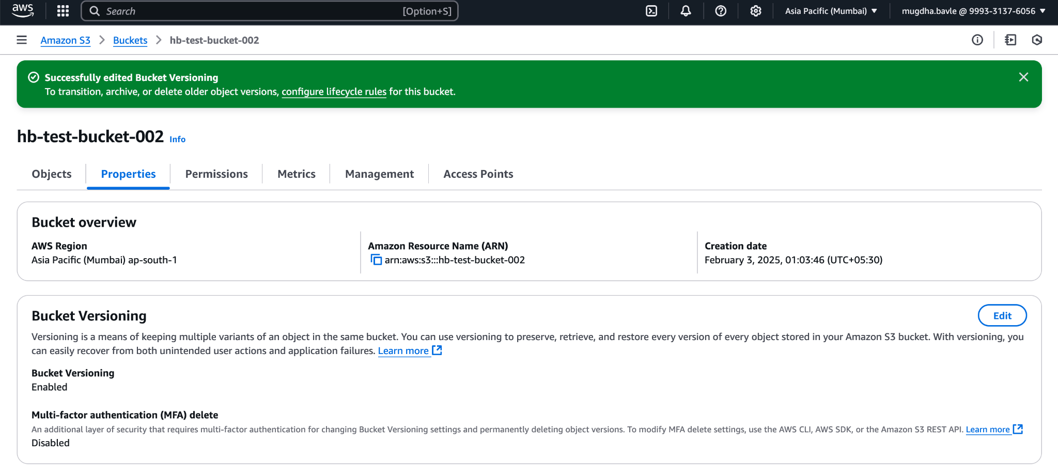
6. Now scroll down to **Object lock** section >> Click **Edit. There will be 2 options shown**
   1. **Disable -** Selected by defailt
   2. **Enable -** We need to select this option to **Enable** Object Locks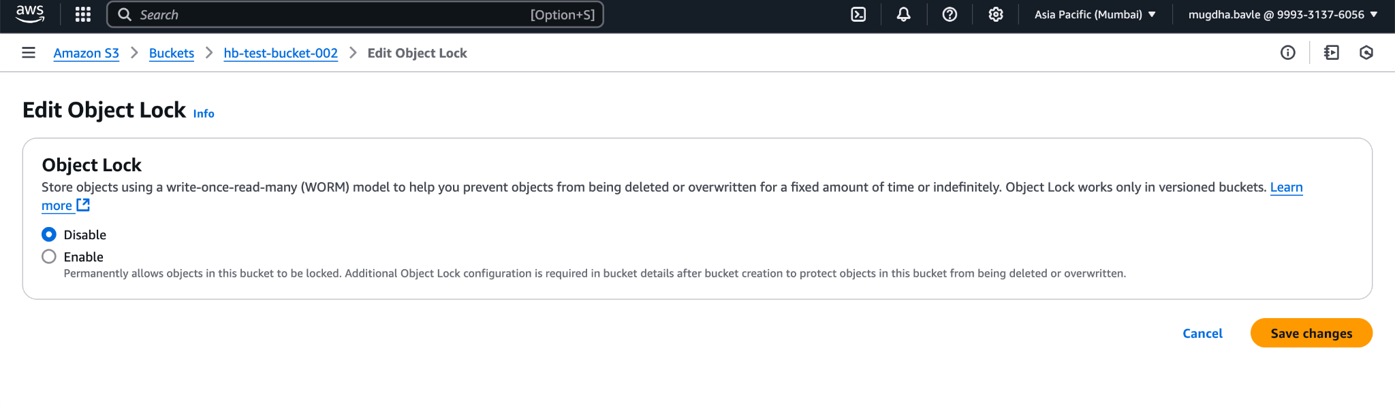
   3. When you select enable, it will show the following screen >> Click on **“I acknowledge…”** in the yellow box >> Click **Save Changes**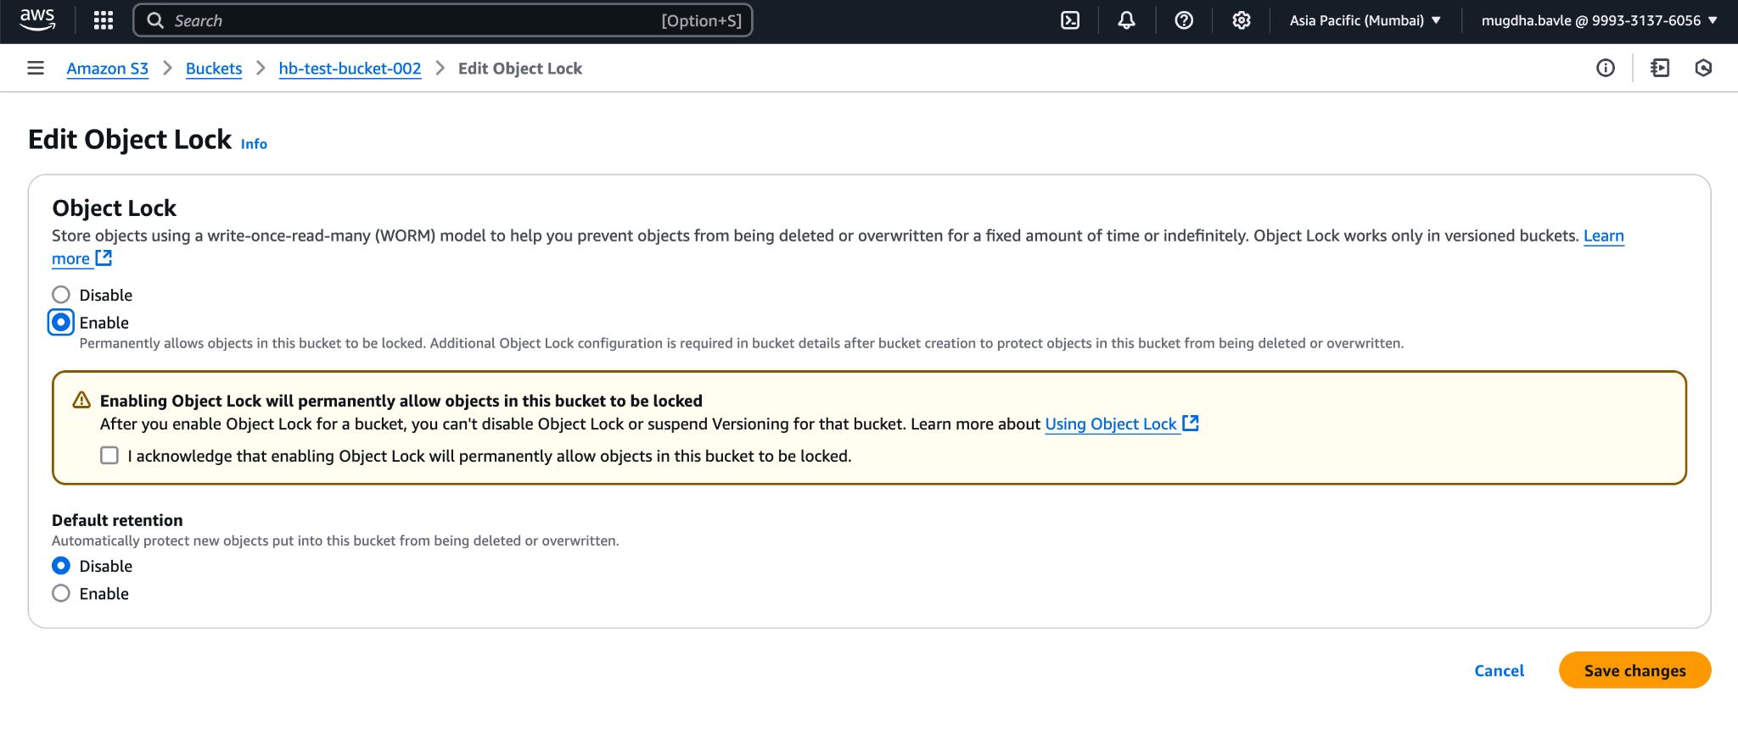
   4. On successful completion you can see the following screen.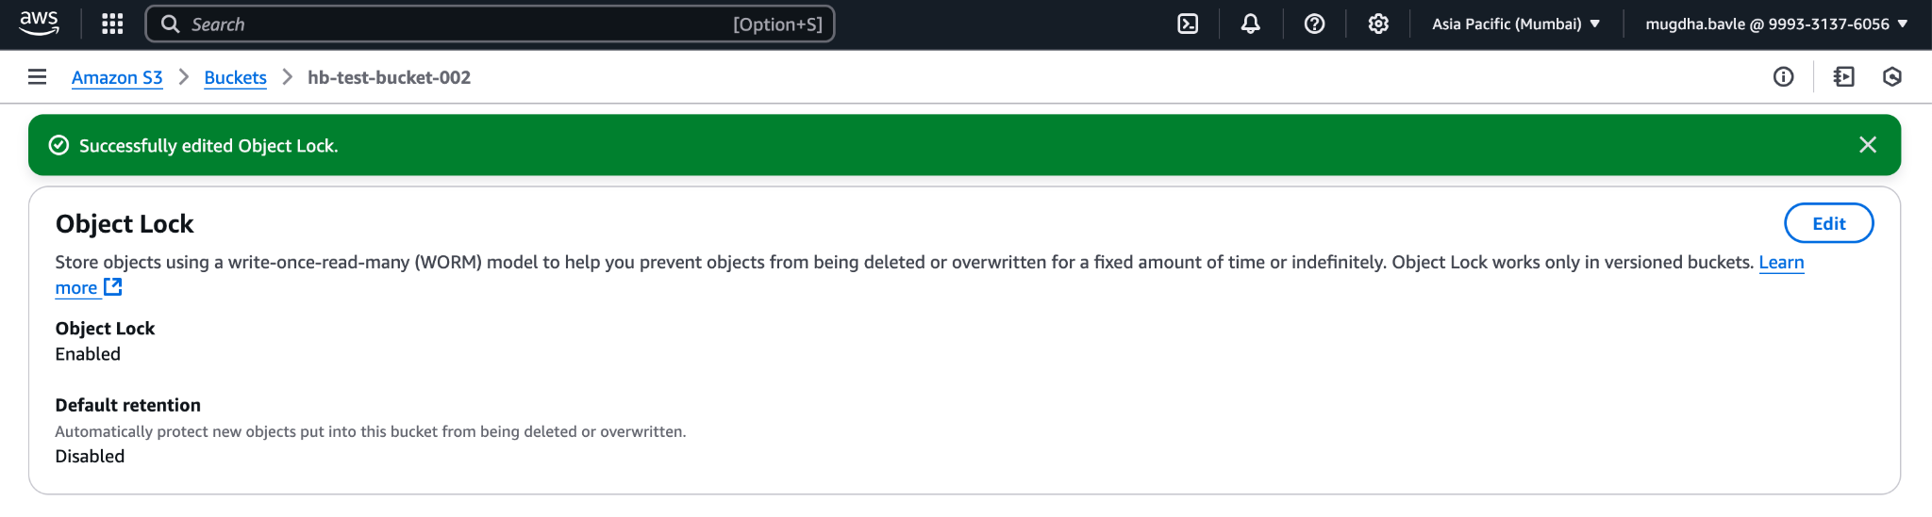

**4. HOW TO LOCK OBJECTS TO AVOID DELETION USING OBJECT LOCK**

1. Click on the S3 bucket you want to modify the **Object lock** for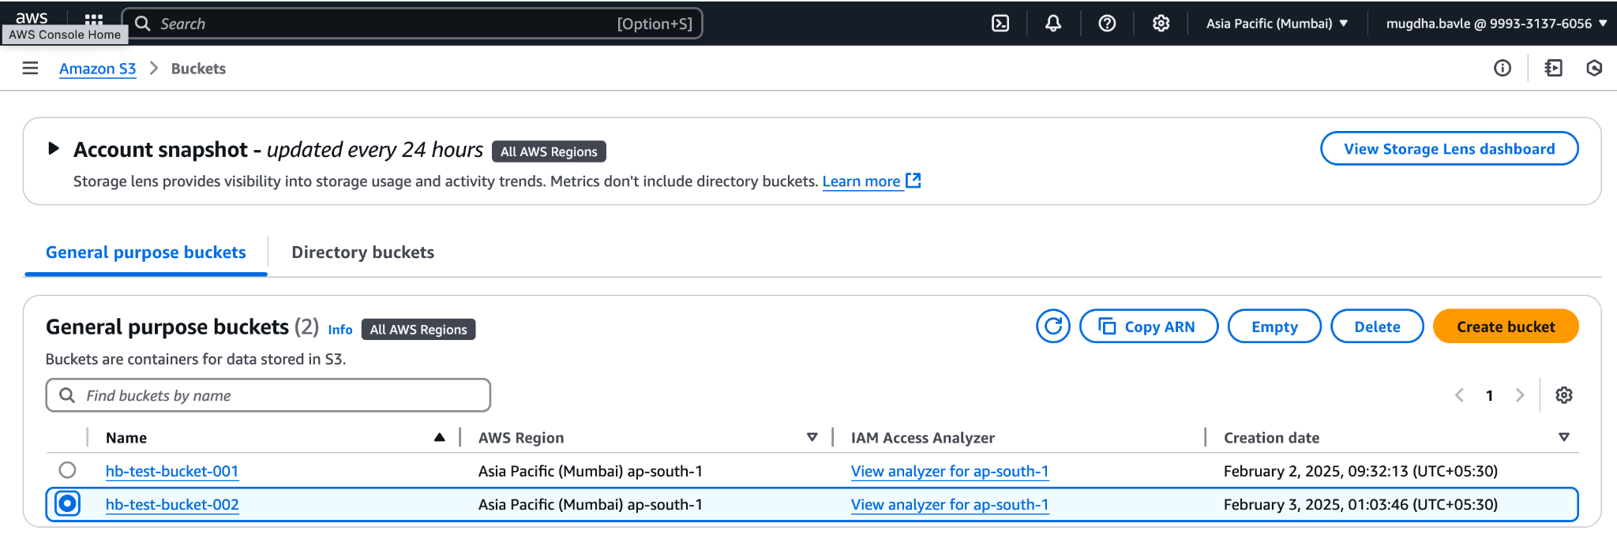
2. Bucket details screen will show as below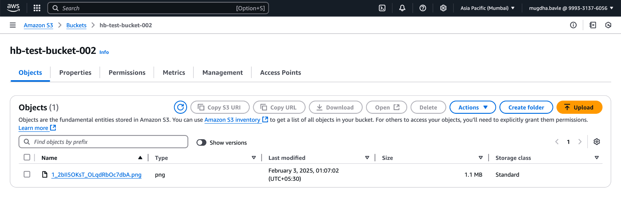
3. Click and open **Properties** tab >> Scroll to **Object Lock** section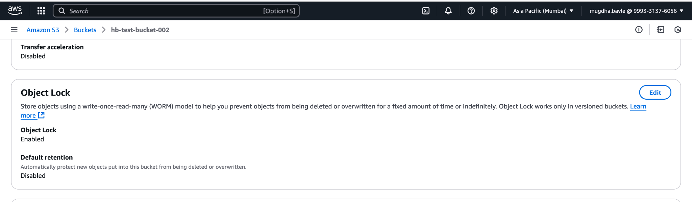
4. Click on the **Edit** button it will open Object Lock details screen
   1. Click on Enable option for **Default Retention**
   2. Select **Compliance** option under **Default Retention Mode**
   3. Type a number in the **Default Retention Period** input box***.(Change the retention period to a lesser number for practice purpose)***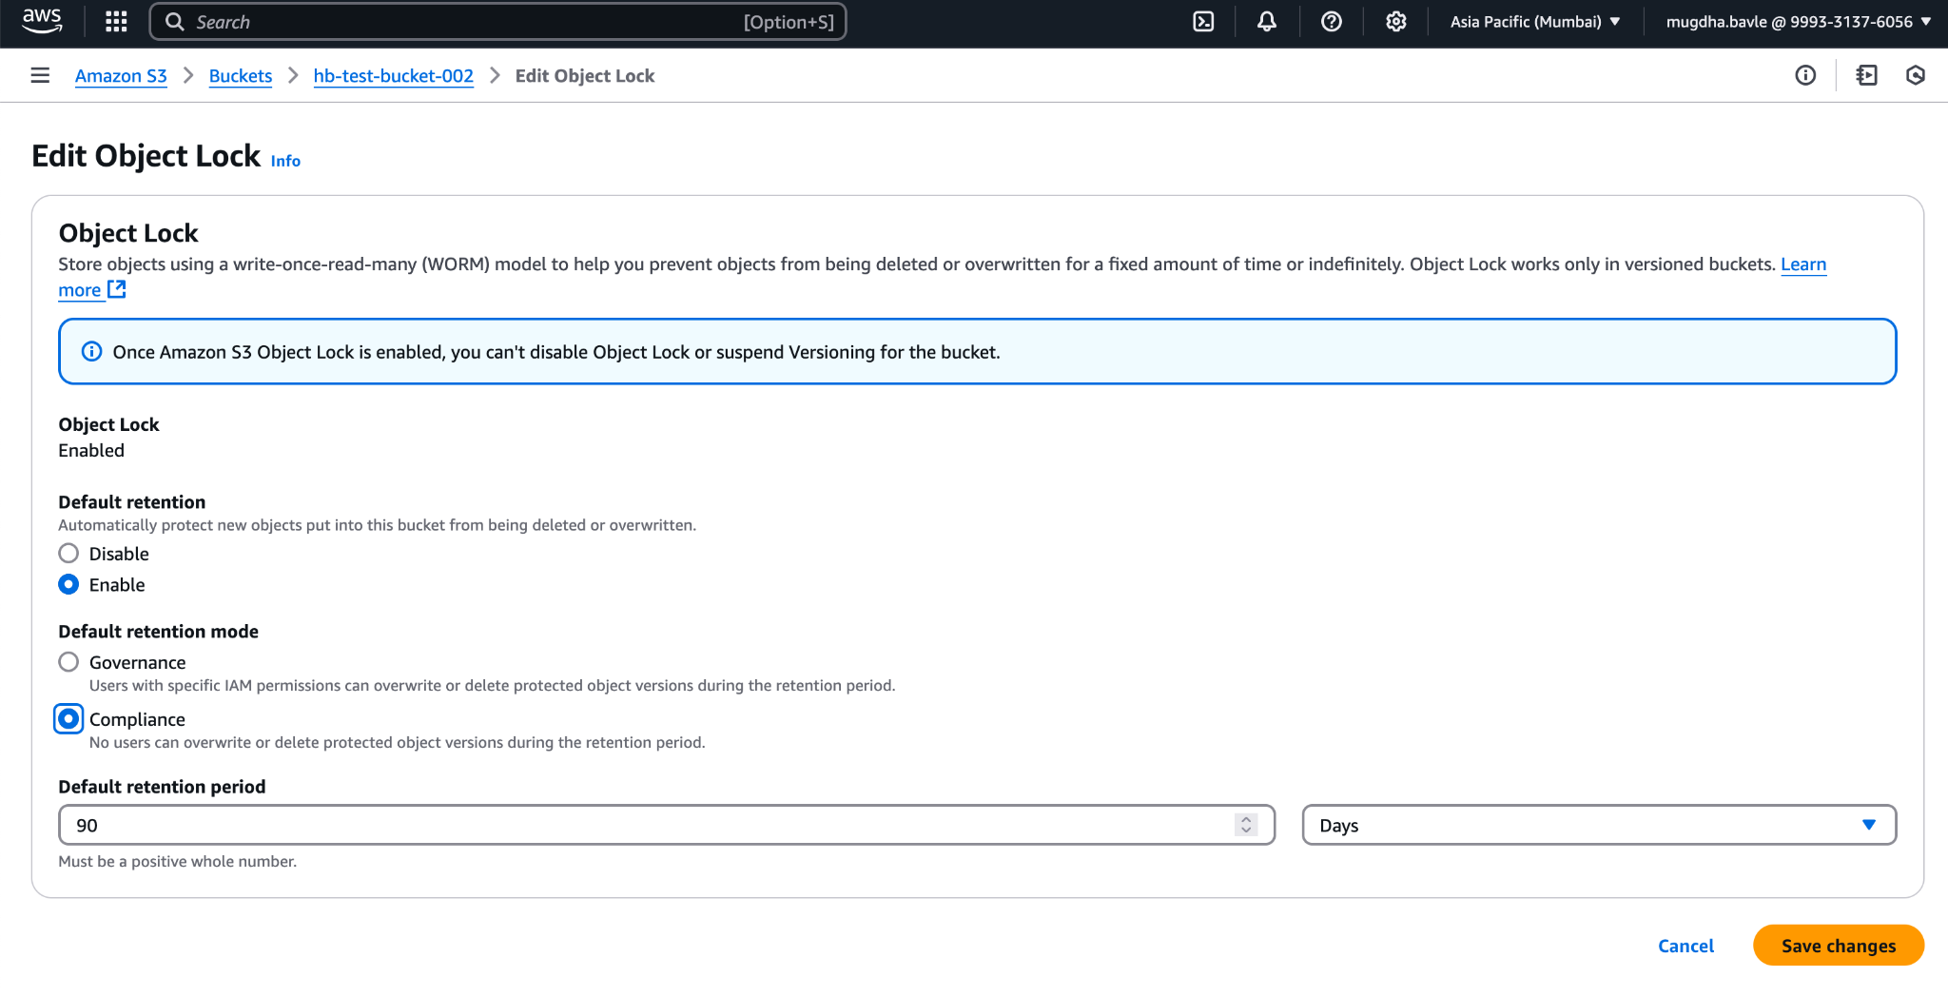
   4. Click **Save Changes** >> It will show a confirmation box >> Type confirm >> Click **Enable Compliance Mode.**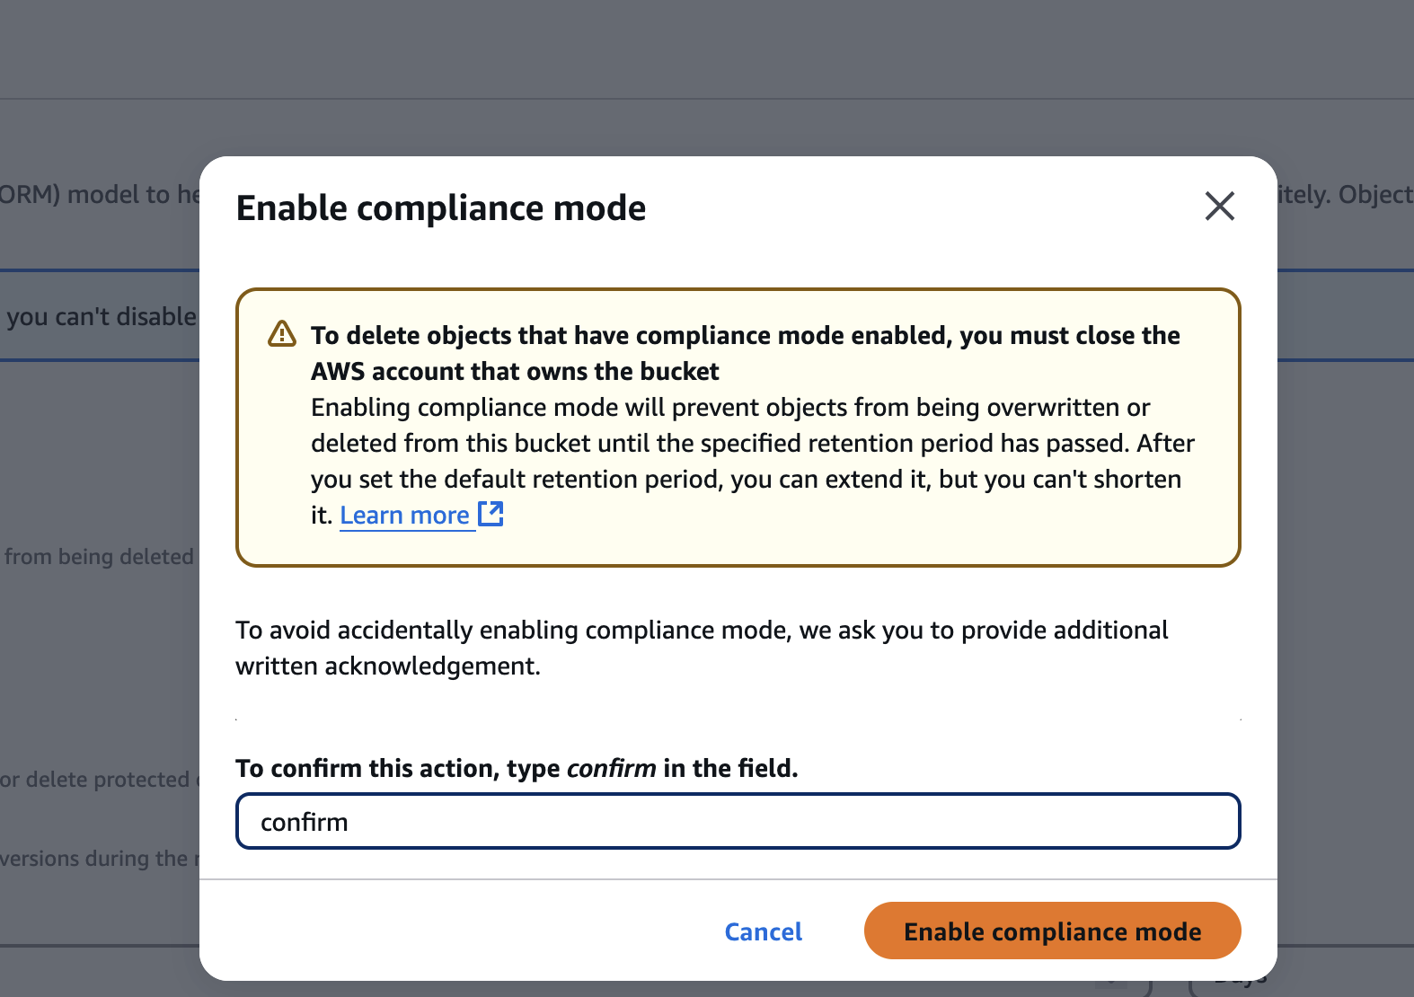
   5. On successful save you will see the following screen with success message.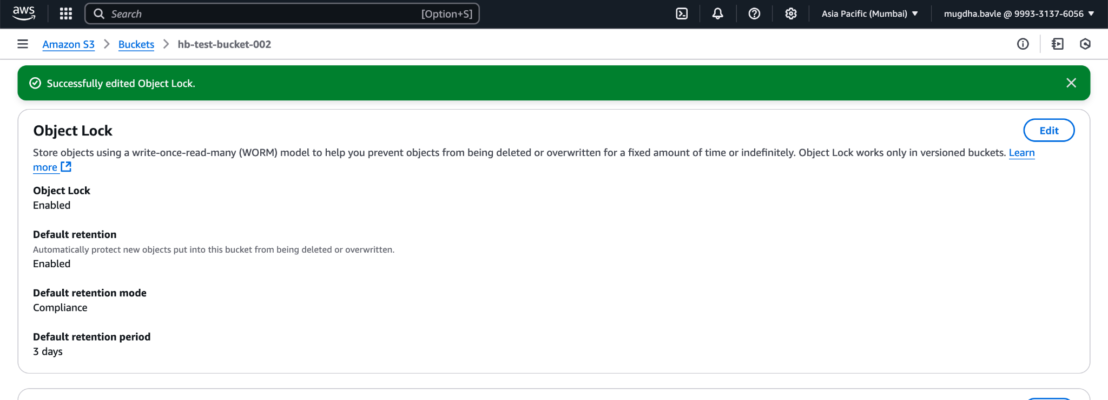

**5. HOW TO CREATE A LIFECYCLE RULE**

1. Log in to AWS Account >> Search for S3 >> Click on buckets and open the landing page
2. Click on bucket name to open details page for the bucket

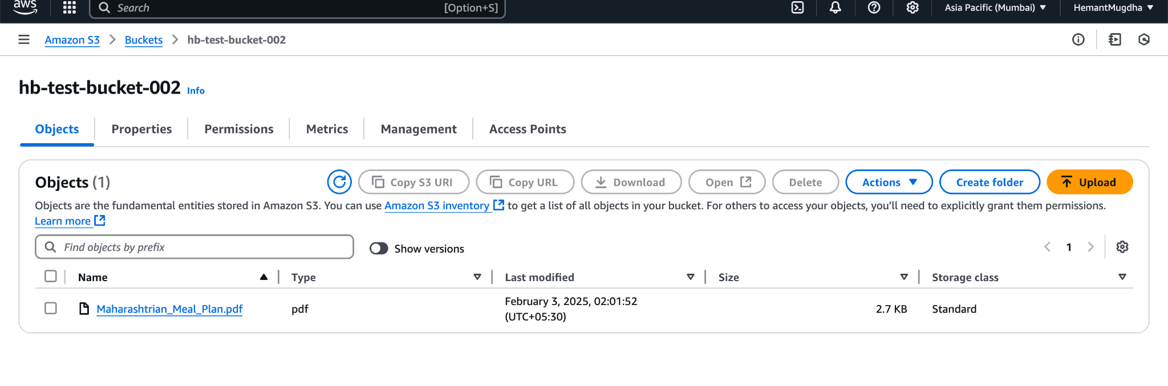

1. Click on Management Tab >> Under **Lifecycle configuration** >> Click Create Lifecycle Rule

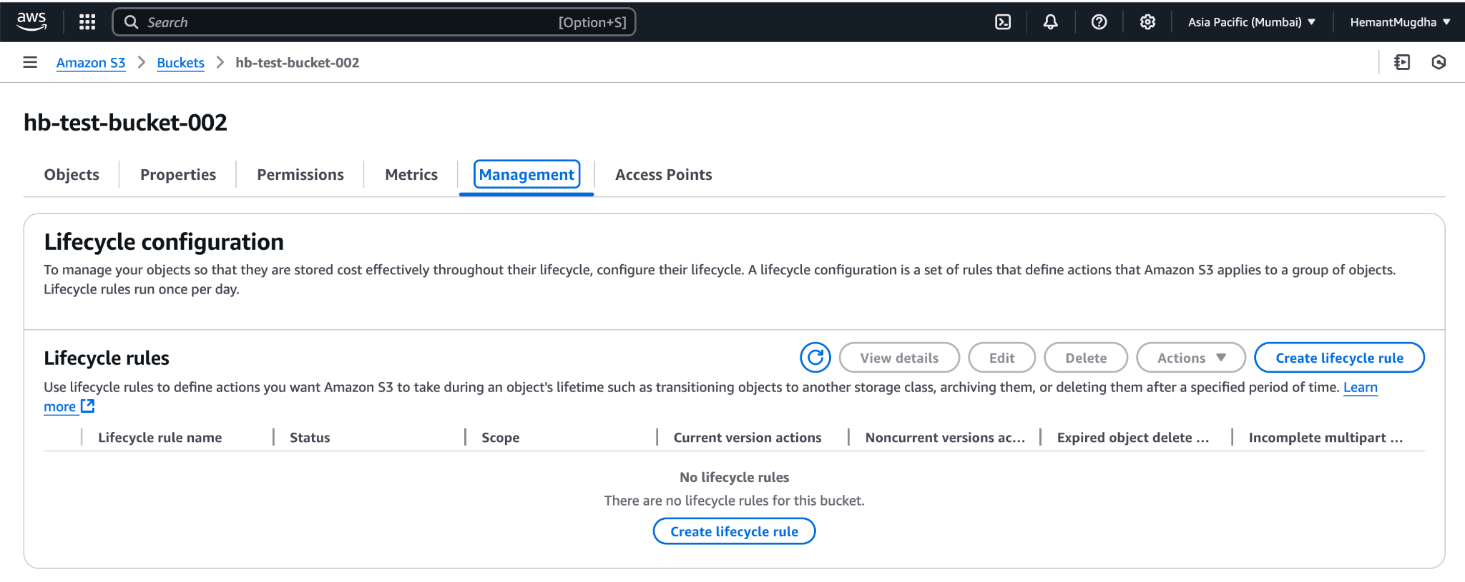

1. On clicking create Life cycle rule >> Wizard to create the rule opens up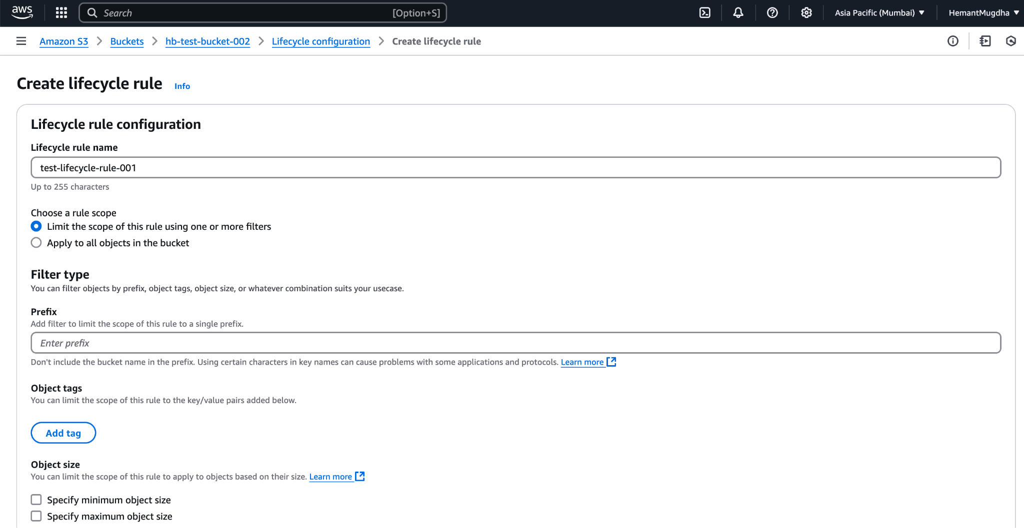
2. Type **Lifecycle rule name**
3. Choose a rule scope >> **Apply to all objects in the bucket >> Yellow message appears >> Tick “I acknowledge…..”**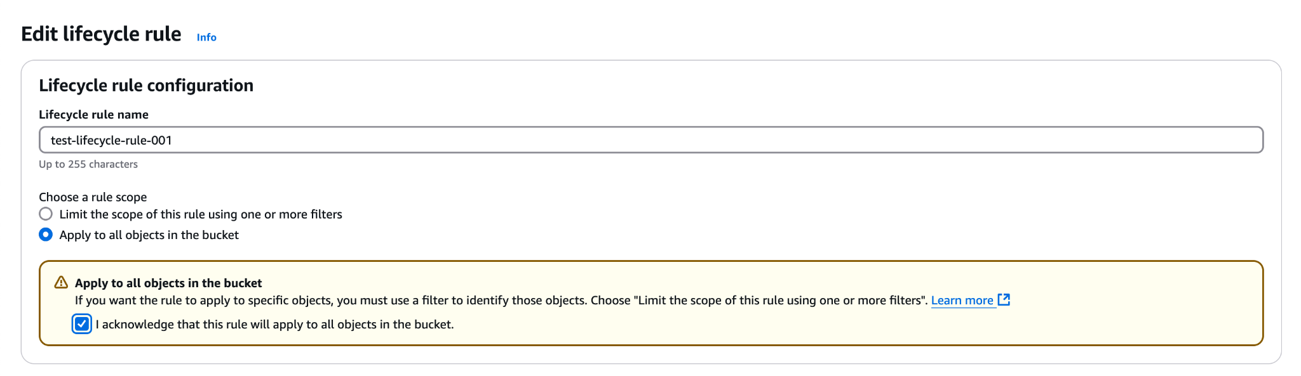
4. Scroll to **Lifecycle rule action** section >> Select the requisite action***(I am choosing for use case of retaining latest n version of objects to be retained)*** >> “Permanently delete nonconcurrent version of objects.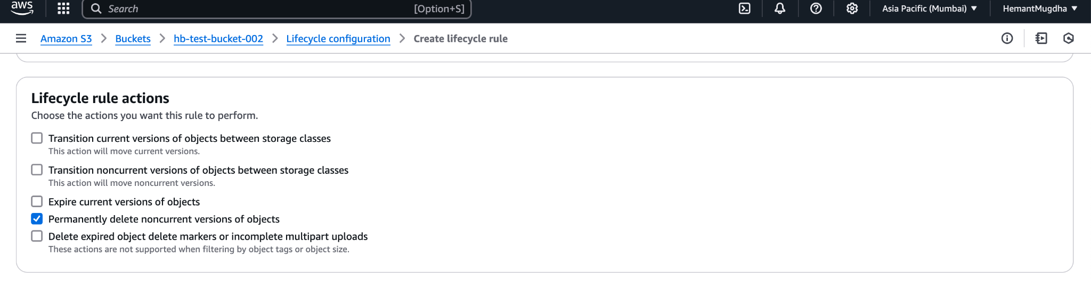
5. Under **Permanently Delete noncurrent versions of object, set the following values**
   1. Days after objects become noncurrent - 90
   2. Number of newer versions to retain - 3

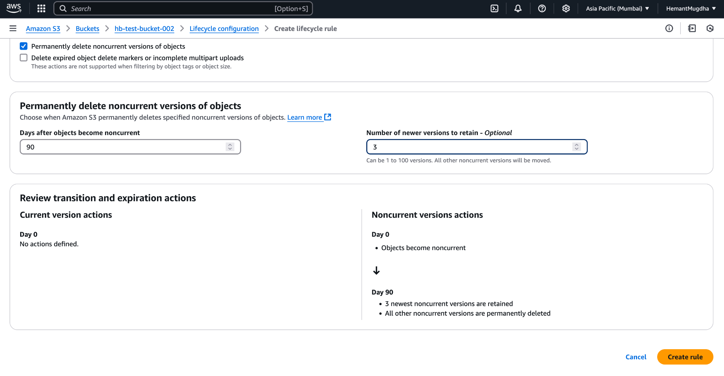

1. Click on **Create rule >> Following should show up on successfull execution.**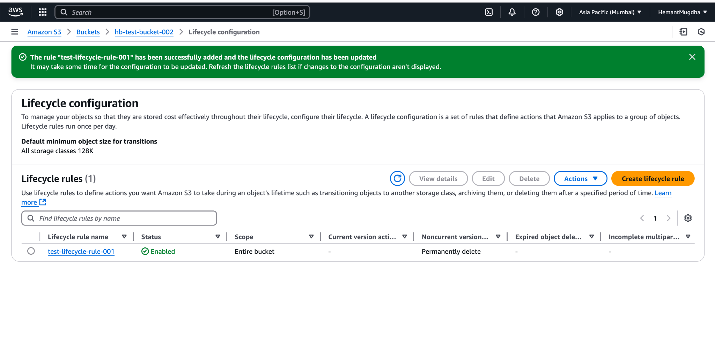

**6. HOW TO CREATE A REPLICATION RULE**

1. Open the S3 bucket details page as done in previous labs
2. Go to Management >> **Scroll to Replication Rule**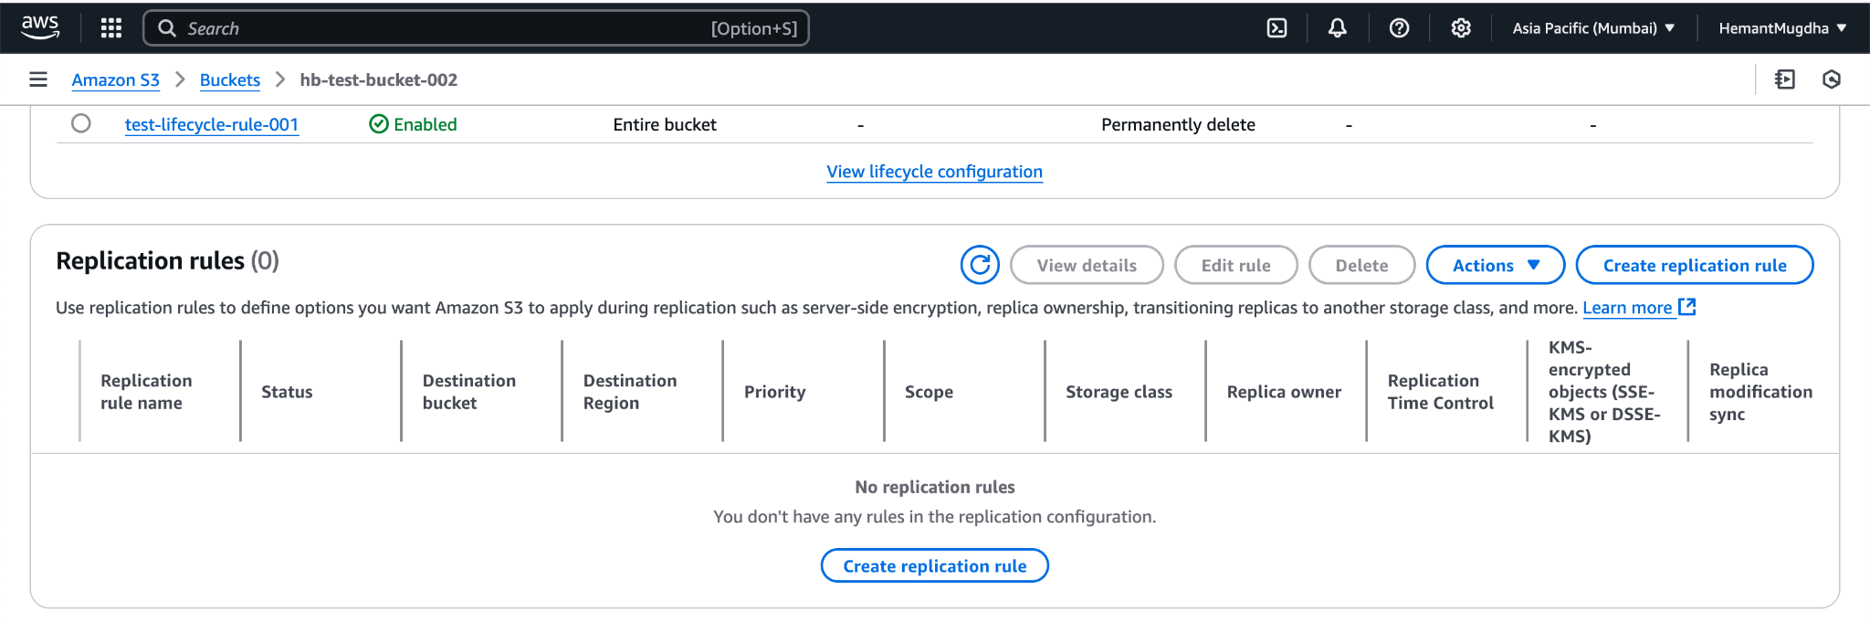
3. Click on Create Replication Rule >> Create wizard opens >> Add **Replication Rule Name >>** keep **Status**  as ***Enabled >>*** Under**Source Bucket** *>>* Choose a Role Scope to **Apply to all objects in a bucket**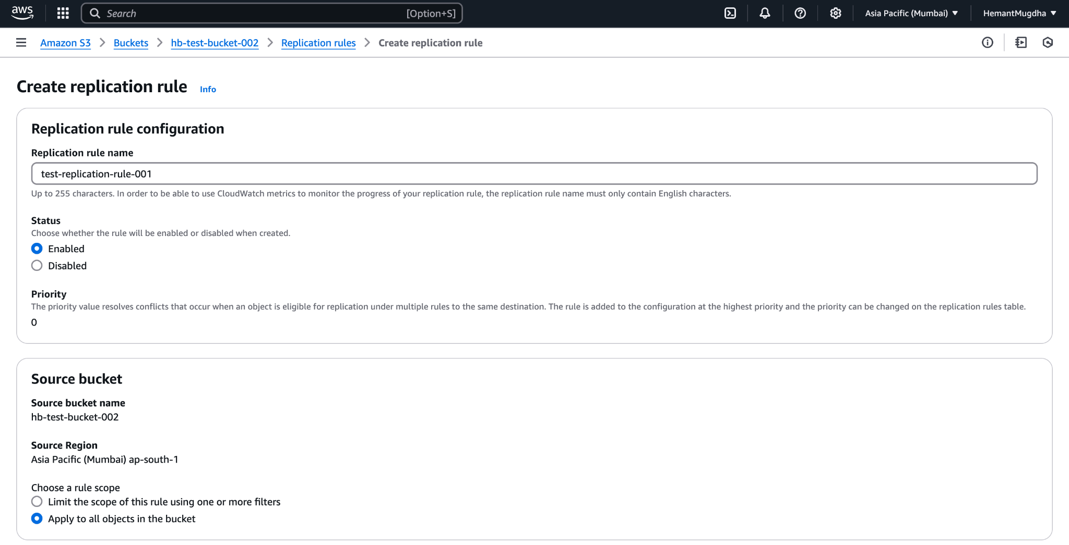
4. Scroll to **Destination** section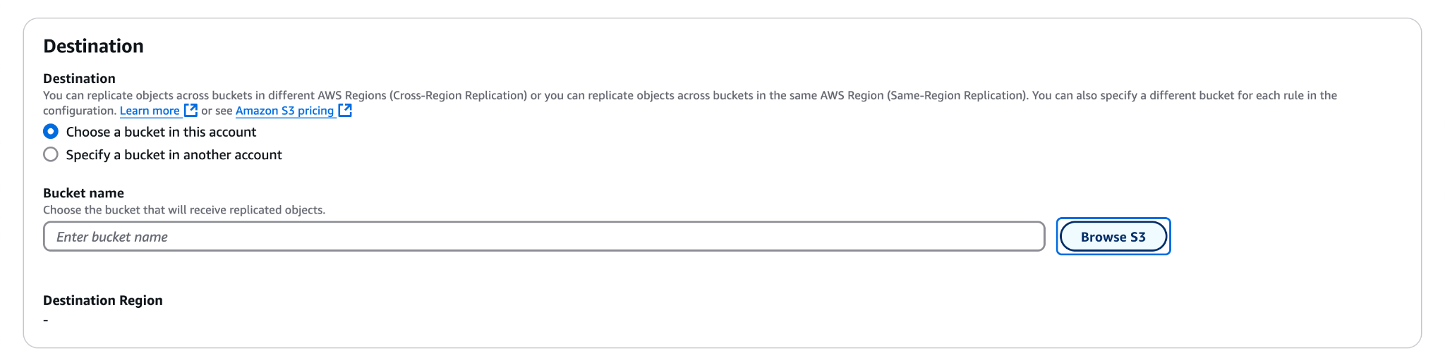
5. Select **Choose a bucket in this account >>** Click on **Browse S3**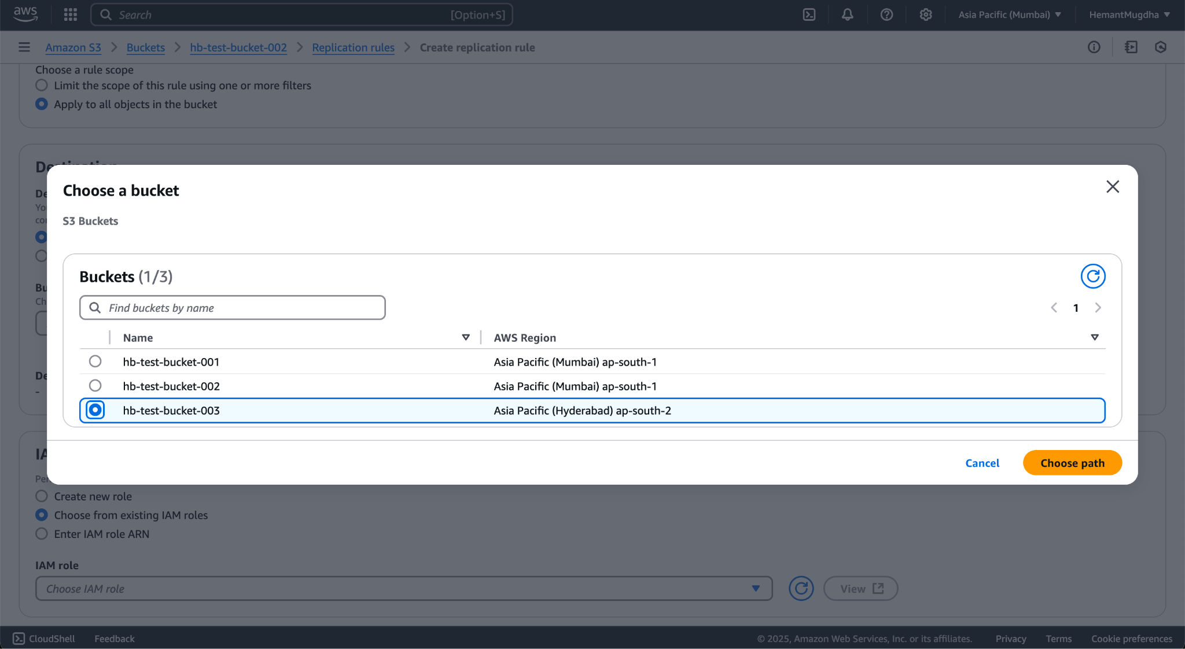
6. Select a bucket in the same or different region(ideally different region). A bucket in different region has been chosen here.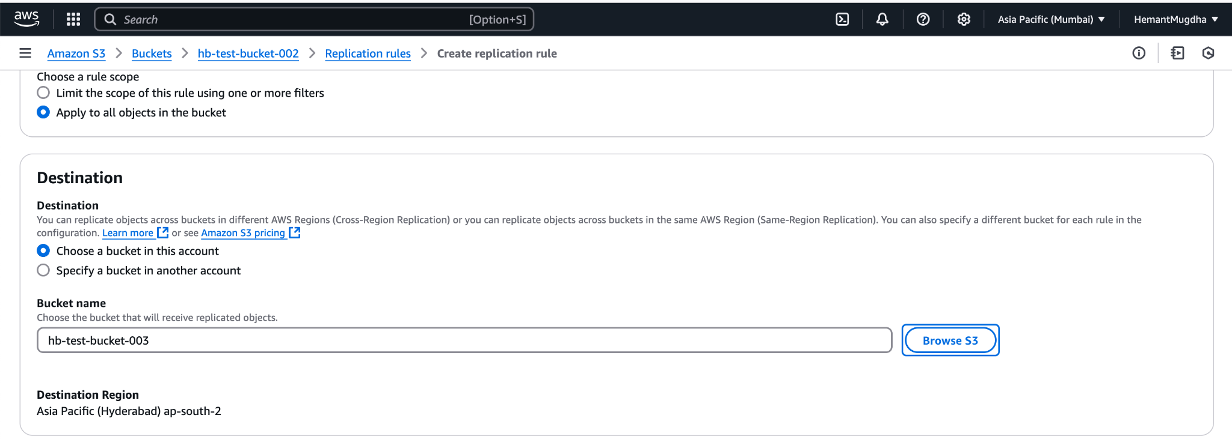
7. Keep all other options as they are and click **Save**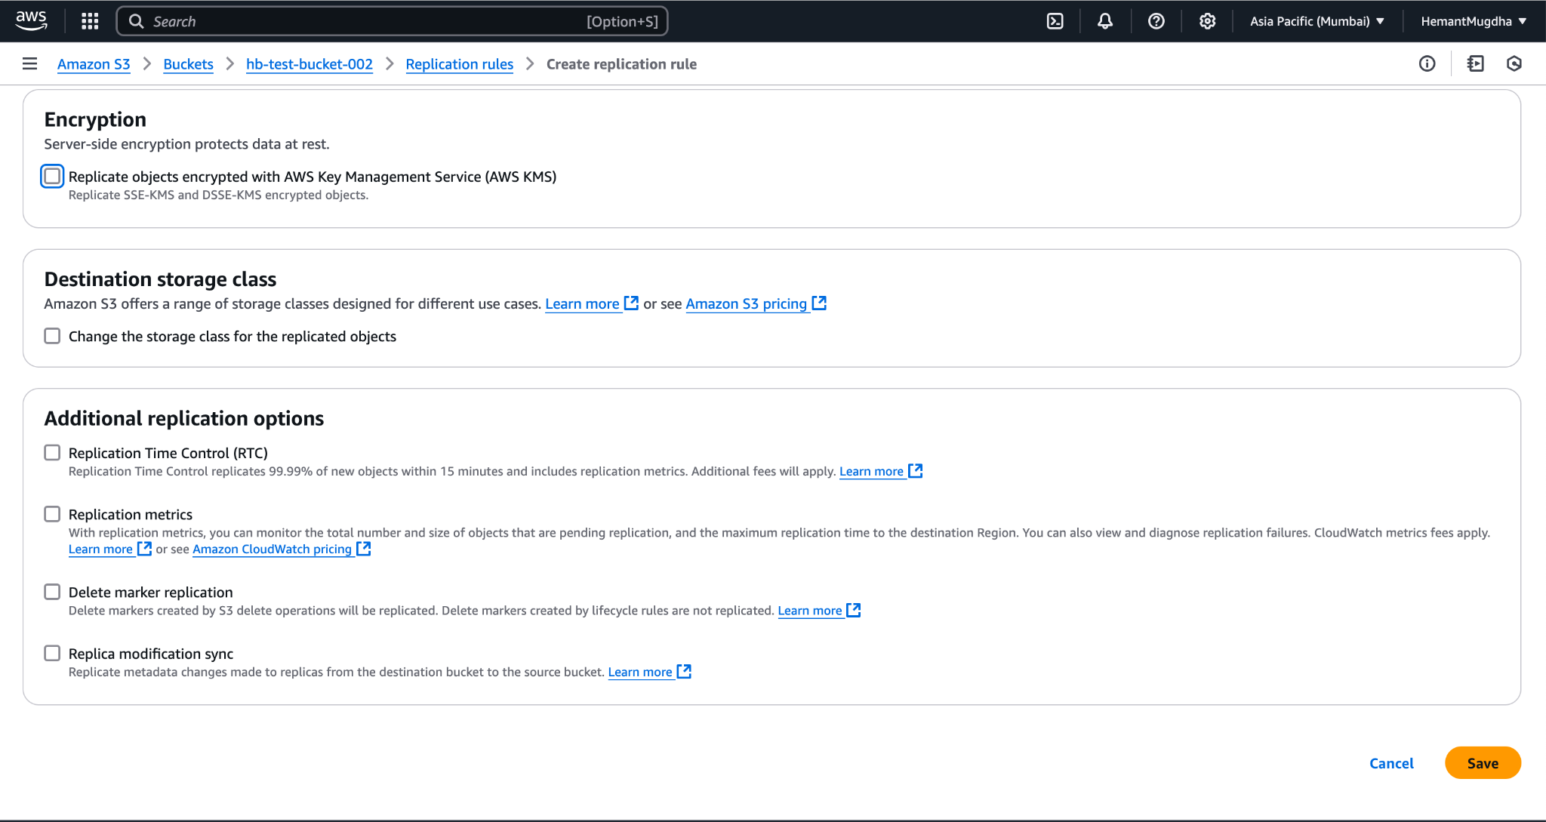
8. On clicking **Save >>** A success message appears in the background >> A modal shows up asking for Replicating existing objects >> Select **Yes, replicate existing objects** >> Click on **Submit.**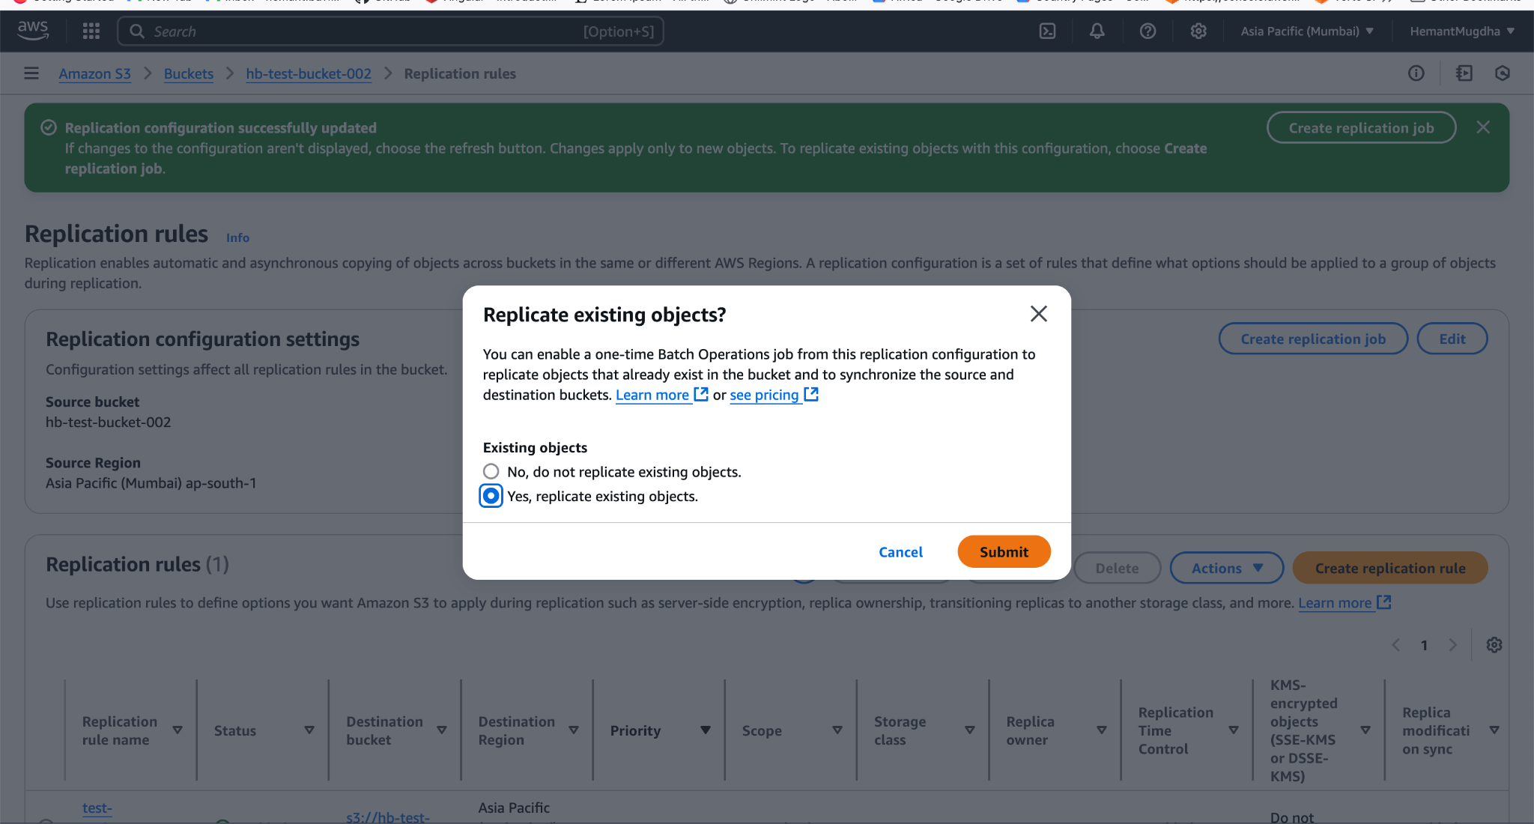
9. A **Create Batch Operations job** screen opens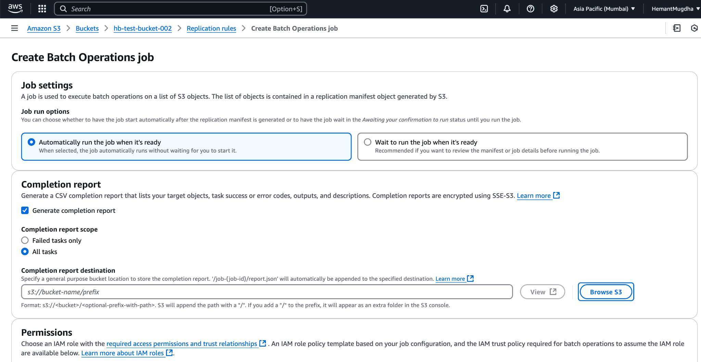
10. Keep the default selections as they are.
11. It provides an option to select a **Completion report destination** >> Click on **Browse S3** button >> Select a bucket
12. Select the role >> click on **Save**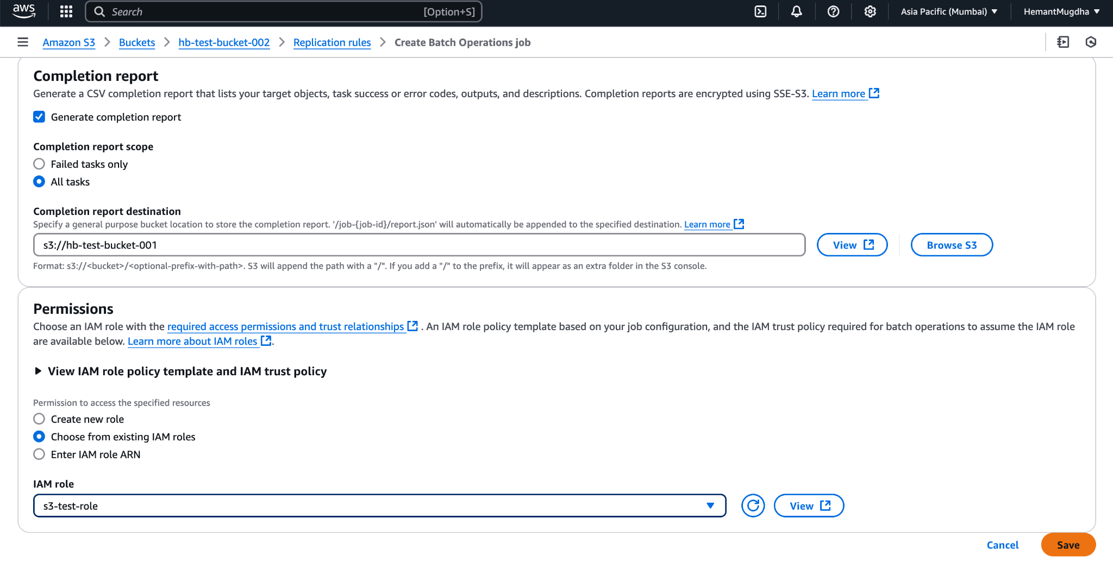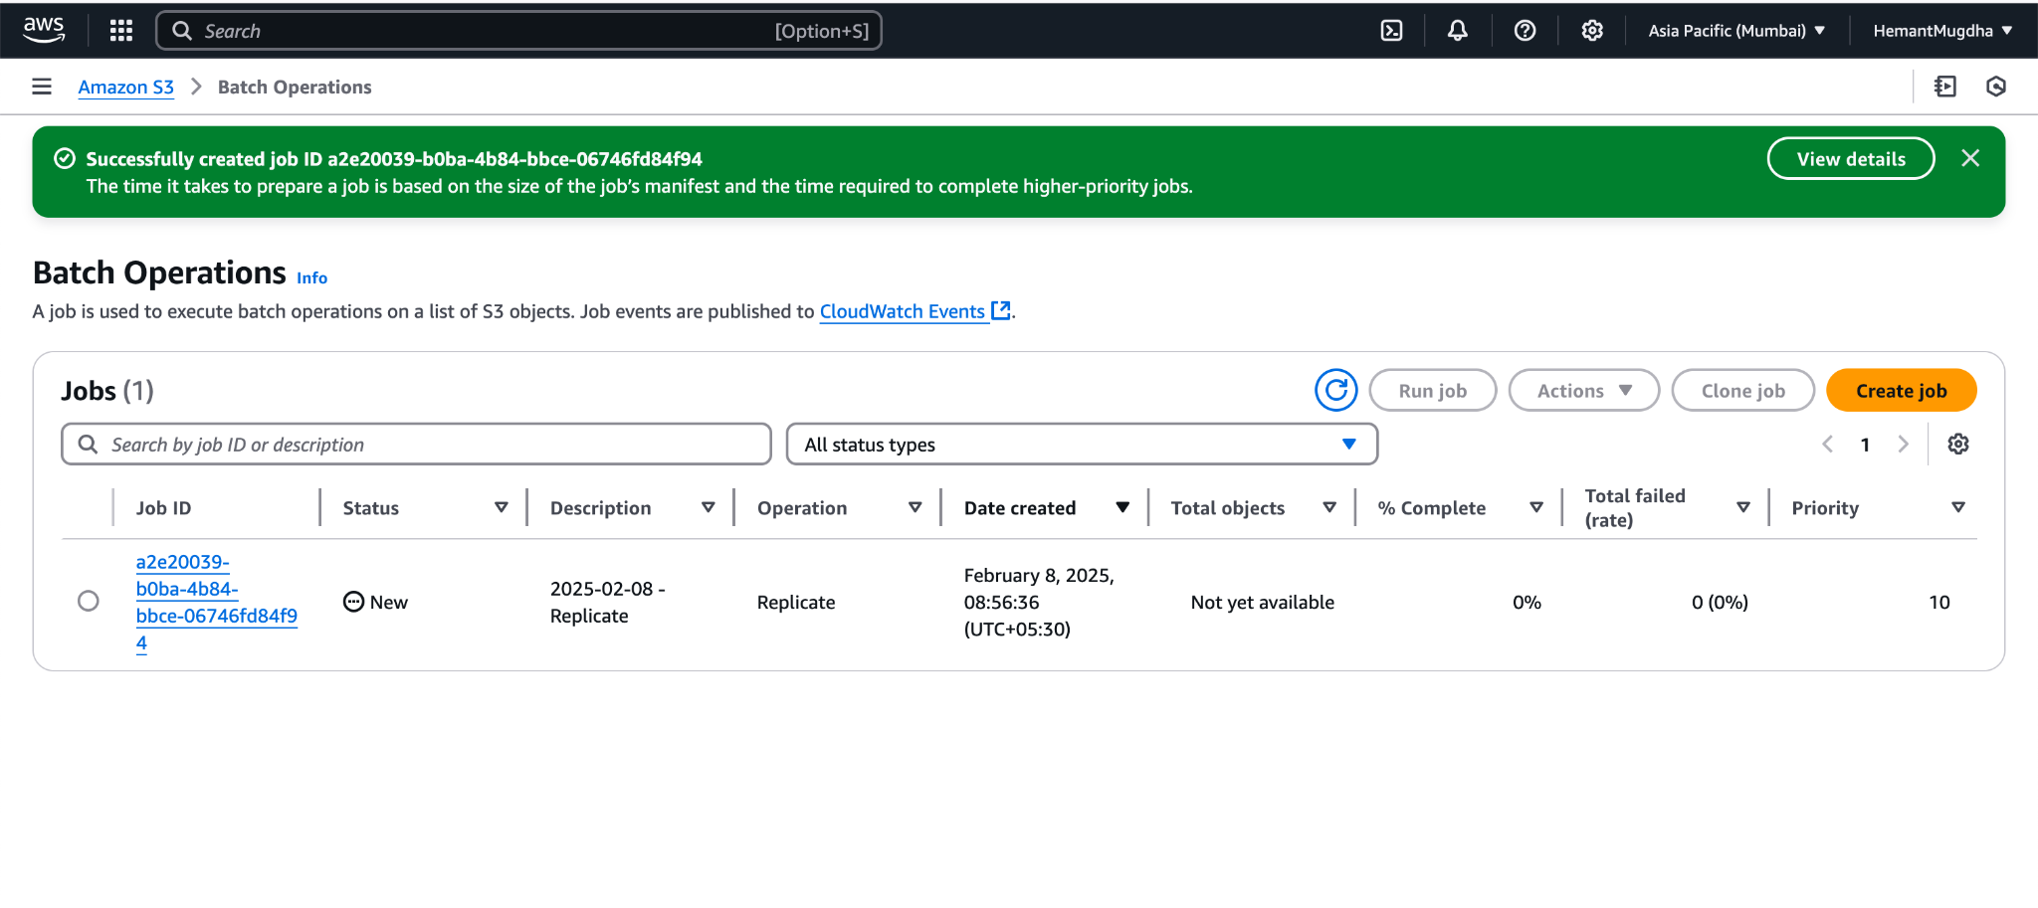
13. On successful completion the job status gets updated and the object from source object become visible on destination bucket